ADMINISTRATION OF MEDICATION
Before you can administer medication independently you need to pass this competency assessment. You need to pass all theory questions. In addition, you will be assessed on two separate occasions on your practical administration of medication and will need to pass all competencies.
COMPETENCY | The correct practice of administration of medications
PRINCIPLE | To ensure that all medications are administered safely to the right participant, at the right time via the right route.  Actions to take in the event of an incident
ASSESSMENT | To assess that the SW has a full understanding of the medication policy and procedure.  To complete the theory assessment  To assess the SW can competently assist the participant with their regular medication.  To monitor and observe the SW during the administration of medications.  To assess that the SW has the knowledge and understanding of the processes required if an error occurs or a behavior is exhibited during the medication administration process.

Administering Medications
Staff
Staff responsible for administering medicines (including where participants self-administer) must:
- be appropriately trained.
- understand the effect and side-effects of medications administered;
- understand what to do in the event of an incident involving medication.
- understand the reporting requirements for incidents.
- understand the escalation procedure for incidents.

Participants self-administering and managing their own medications.
- Participants will manage and administer their own medication where appropriate.
- Where required, the Director (or delegate) will request written advice from a participant’s medical practitioner or guardian, notifying that a participant has appropriate training and skill to assume responsibility for the management of their own medication.
- Participants will be provided with every opportunity to safely manage and administer their own medication.
- The self-administration and management of medications by the participant is properly supervised, documented and recorded by Organisation staff.

Participants unable to self-administer their own medications.
- Staff members are to provide the participant with whatever physical or other assistance is necessary and appropriate to enable the participant to take their own medication, unless the participant objects.
- Staff who provide medication administration services will be provided with appropriate training.

Practical Requirements for the Administration of Medications
- All medication must be administered in strict accordance with the directions of the prescribing medical practitioner or the manufacturer’s directions as appropriate and recorded on the appropriate medication chart.
- All participant medications are to be taken or administered from webster pack or from the original containers or packages for medication that cannot be webster packed.
- Medication is not under any circumstances to be given out or administered to a participant by another participant.

Prohibited practices.
- Staff must not administer any medication that is not prescribed in accordance with this policy, including ‘over the counter’ medication.
- Staff must not administer medication to a participant who is clearly objecting in an informed manner, unless there is an approved protocol in place.
- Staff must not administer medications to participants in a manner that is clearly for organisational convenience and not reflecting the preference or needs of the participant.
- Staff must not leave medications of any type in an area where they are unsupervised and accessible to participants or unauthorised persons.

Medication Records
- A medication chart is to be maintained for each participant prescribed medication. The chart is to be completed and updated whenever a medication is changed.
- Where a staff member has uncertainty about a participant’s medication, this should be immediately clarified with the participant’s (and/or participant representative) or the dispensing pharmacist.

Storing and Disposing of Medication
Storing Medication
- Medication for all participants must be stored in a locked container (e.g., filing cabinet or cupboard), which can only be accessed by appropriately trained staff.
- All medication must be easily identified and differentiated.
- The Director (or delegate) is responsible for the security of all medication stored on AMPEY PTY LTD premises.
- Staff must adhere to the manufacturer’s instructions for storing each medication.
- When medication needs to be transported, it should be placed in an appropriate storage container where required.

Disposing of Medications
- All medications (including those self-administered and managed by participants) are to be returned to the pharmacist when ceased or disposed of as per the Clinical Waste Disposal Policy and Procedure.
- No ‘prescription only’ medication may be kept as AMPEY PTY LTD stock. Any participant’s medication is to be returned to the participant at the end of the medication regime.
- No medications are to be used by or for another participant or kept or allowed to accumulate with other participant’s medication for use sometime later as ‘stock’ medication.
- See the Clinical Waste Disposal Policy and Procedure.

Reporting
Incidents relating to medication misuse are Reportable Incidents and should be reported to the NDIS Quality and Safeguards Commission in accordance with the Incident Management Policy and Procedure.

The six “R’s” rights of correct medication administration
Right Person Check photographic identification on the blister packs and the medication chart and administration record to ensure the medication is for the right person.
Right medication Check the name of the medication on the blister pack or medication packaging against the name on the medication chart for the person.
Right dosage. For blister packs, check that the right number of tablets or pills are contained in the blister. For other medication ensure the dose is clearly documented on the pharmacist’s label attached to the medication
Right Time Ensure the medication is being taken at the prescribed time. Some medications will have further instructions that must be followed such as, to be taken with or before food.
Right Route Ensure medication is taken, applied or inserted using the prescribed route. This maybe oral, topical (external), by inhalation, or peg.
Right Documentation All medication must be recorded, and the appropriate medication chart signed by the person administering the medication and where applicable cosigned by another staff member.
Right Reason Confirm the rationale for the ordered medication. What is the participants history? Why are they taking this medication?
The participant has the right to refuse any medication.

“Medication errors are a problem in Australia, as they are in other countries. Previous estimates indicate between 2% and 3% of all Australian hospital admissions are medication related. This suggests at least 230,000 admissions annually in this country are caused by patients taking too much or too little of a medicine, or taking the wrong medicine” – Australia joins international push to halve medication errors | Australian Commission on Safety and Quality in Health Care
A medication error is a failure in the treatment process that leads to, or has the potential to lead to, harm to the patient.
Reporting of errors should be encouraged by creating a blame-free, non-punitive environment.
The incorrect use and management of medications provides a significant risk for participants and has the potential to cause harm due to adverse drug reactions or events.
At the start of shift, it is your responsibility to check if your customer has medications while you are on shift.
Check the medication patient summary.
Check the webster pack or packages for correct medications against doctor’s approval.
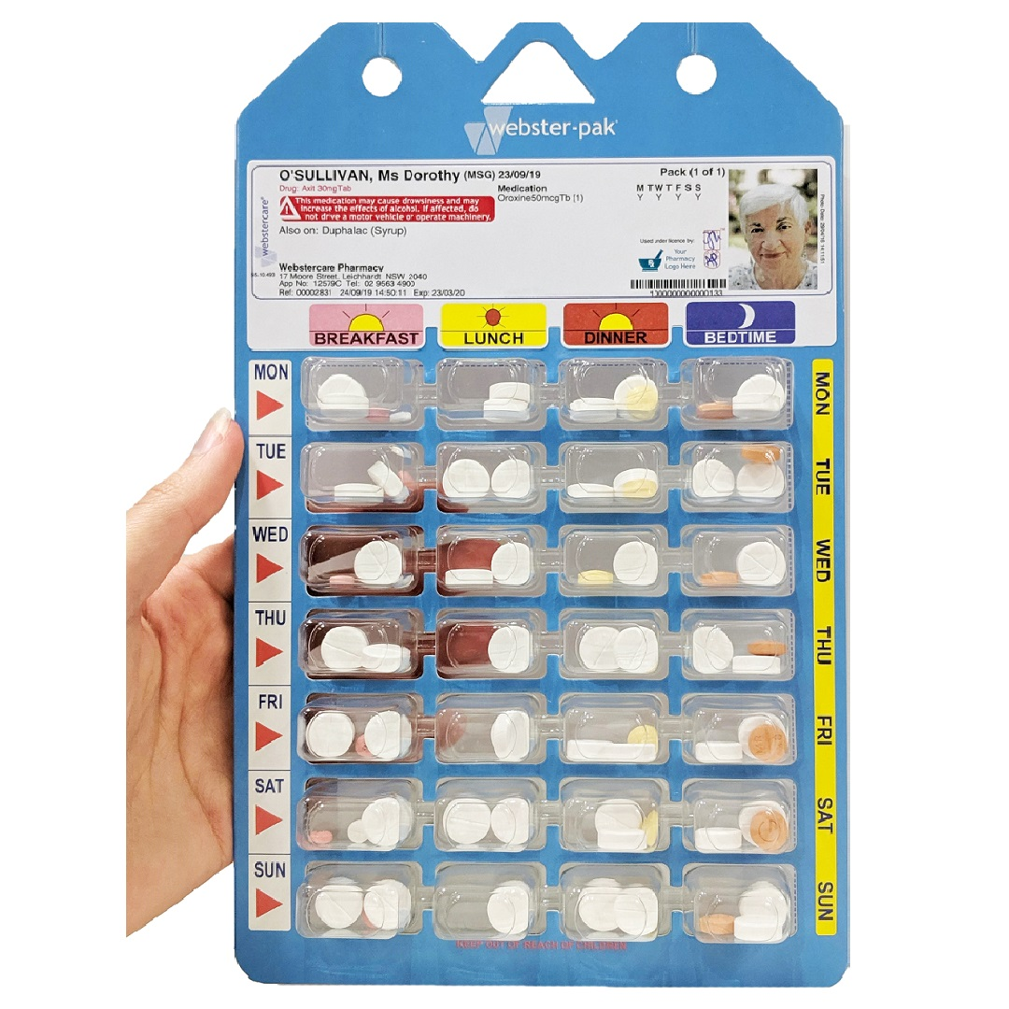
All medication that the participant is prescribed will have a medication facts sheet that will describe the medication and what it is used for and any side affects and what to do if side affects are identified. Staff are to have read and signed before administering medication.
If there is any discrepancy identify this to your manager immediately do not administer. Call the health direct line on 1800 022 222 and follow their instructions. Complete incident report.
If you drop a medication while administering you are not to administer. The medication is to be placed in an envelope and returned to the pharmacists. Medication that you will administer is from another pack or the latest one from the original pack to give you time to have the pack redone. Complete an incident report.
If a participant spits out a medication you are not to readminister. You are to call the poison information line on 13 11 26 or health care direct line on 1800 022 222 and follow their advice. You can also call the chemist. Follow their instructions and record information in incident report.
If medications are out of date do not administer. You are to call the poison information line on 13 11 26 or health care direct line on 1800 022 222 and follow their advice and contact management and complete incident report.
Participants who are not capable of managing their own medications independently, or with minimal assistance, will have medications administered by staff.
In preparation for administering medications staff must complete the following process.
Only administer one participant’s medication at a time.
Where staff are required to administer medication to more than one participant at the same location, a single staff member is to be allocated the role on the start of shift and recorded in the shift report person responsible. This staff member will be responsible for the administration of all participants medications. This eliminates errors of forgetting medication and possible double doses being administered.
If there are two staff on shift always have the second staff member check the blister pack and cosign the medication chart. If only one staff member on only one signature is required.
When administering medications in a supported living environment staff are to wear a coloured vest when administering medications as this identifies the staff member as completing this task and assists in re-directing participants while medication administration in in process to reduce the risk of errors.
Where staff are supporting participants out into the community who require medications while out the follow procedure is required:
Staff are to check blister pack and doctors’ letter and administration chart and collect the medication required. The medication is to be in a locked bag that keeps the medication at the recommended temperature and storage. The locked bag is to always remain with the staff member. When administering medications in the community staff are to follow the same processes as when administering in home.
Wash your hands before and after medication administration.
Wear disposable gloves, use non touch technique (use a pill Bob, when applicable) for tablet medications.
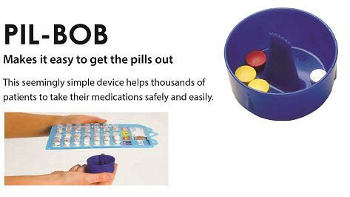
Medicine cup for liquid medications or syringe if stated in the process of how to administer medications.
Check the medication patient summary.
Check the webster pack or packages for correct medications against doctor’s approval.
Talk to the participant and explain to them what is happening that you are going to administer their medications.
Make sure you have everything your need to administer the medications.
Ask the participant if they know what their medications are for. If the customer is no verbal still complete this process.
Check the photo on the medication chart and the blister pack match the customer.
Use appropriate PPE.
Wait with the customer while they take the medication and check it has not fallen or spat out.
Sign off on the administration of the medication on the medication chart.

Medication can come in different prescriptions:
Routine medication is medications that is taken routinely by the participant. Everyday, Every second day etc.
Prescribed PRN is medication or creams the doctor has prescribed that is to be taken when required. This medication will have instructions on the patient health summary and permission to administer chart. e.g., Panadol every four hours for headache or pain. Medication is still webster packed or in clearly labeled package. No medications that are not prescribed are to be administered. This includes vitamins. If a participant requires vitamins these must be signed off by a doctor and blister packed or clearly labeled. This is due to the doctor would be the only person that would know if a medication the participant is currently taken is affected by a particular vitamin.
Short term medication is medication that a participant might need to take for a short period of time. This could be a trial medication or antibiotics. This medication is to be treated the same as routine medication and provided in blister packages or labeled packs and only given for the duration as stated by the doctor.
Psychotropics Medication. Psychotropic medications are medications that can affect the mind, Emotions and behaviors for a person. At times participants may be prescribed psychotropic medication.
When a psychotropic medication is prescribed for the primary purpose of influencing a person’s behaviour this is what is classed as a restrictive practice and known as chemical restraint. This medication can not be administered without a restrictive practice approval from the NDIS commission. For further information on what is a psychotropic medication go to List of psychotropic medications - Wikipedia or What Is a Psychotropic Drug? Types, Uses, Side Effects, Risks & More (healthline.com) It is the responsibility of your management to ensure a restrictive practice approval is completed and approved in this instance.
For more information on regarding Chemical restraints and restrictive practices please refer to the Disability Regulated Restrictive Practice Procedure and /or the NDIS Commission Regulated Restrictive Practices.
Psychotropic medications that have been prescribed for the treatment of a mental health disorder and physical illness or physical condition by a medical practitioner is not considered to be a chemical restraint and can be administered. Always seek advice if you are unsure.

Medication errors, omissions or adverse reactions
Medication errors can occur for several reasons, including human and other factors affecting how medicines are prescribed, dispensed or administered.
All medication errors and incidents must be reported as soon as identified. All incidents relating to medications must be reported to the supervisor immediately.
An error or incident may include but not limited to:
A medication was not administered.
You suspect medications have been administered incorrectly maybe twice.
If the wrong medication is given to a participant.
If medication is dropped
If medication is spat out
If the participant is suspected of suffering an adverse reaction.
In the event of a medication incident call the appropriate medical advice or call and ambulance if serious. Notify management and complete incident report.

Name:
Medication Theory
How should all medications be stored?
______________________________________________________________________________________________________________________________________________________
How should medications be stored when in the community?
___________________________________________________________________________
___________________________________________________________________________
What should medication be administered from?
___________________________________________________________________________
___________________________________________________________________________
What should you check when administering medications?
___________________________________________________________________________
___________________________________________________________________________
What is the name of the equipment used to remove medications from blister pack?
___________________________________________________________________________
What are the 6 ‘R’s” of medication administration?
Right
Right
Right
Right
Right
Right
What are the different routes of medication administration?
__________________________________________________________________________
__________________________________________________________________________
___________________________________________________________________________
___________________________________________________________________________

Name 3 possible medication errors?
___________________________________________________________________________
___________________________________________________________________________
___________________________________________________________________________
Describe what process you would do if there was a medication error identified?
___________________________________________________________________________
___________________________________________________________________________
___________________________________________________________________________
___________________________________________________________________________
___________________________________________________________________________

Competency | First Assessment |  | Second Assessment
Washes and sanitizes hands prior to medication administration
Looks at the name, photo and documented special considerations on medication chart and allergies.
Checks the participant s name, date, time of day, and each medication in the blister pack compares with the medication chart.
Counts the number of medications.
Removes the correct dose using the appropriate tools
Utilizes crushing equipment if tablets need to be crushed
Check again for the right time and participant’s name. Speaks to the participant and waits for response, and permission to proceed.
Ensures participant has swallowed medication.
Signs the appropriate medication charts
Makes notation of any medication administration exceptions and uses.
Can competently describe the process if an incident was to occur.

Assessor signature First Assessment:_______________________Date________________

Assessor signature Second Assessment:_______________________Date_______________

